CBC NewsPolitics

'You're seeing how callous they are': Ottawa spent a fraction of promised money on First Nations health

Despite slow start, Health Canada says 3,000 children have been helped by new Jordan's Principle funding

By John Paul Tasker, CBC News Posted: Feb 08, 2017 5:00 AM ET Last Updated: Feb 08, 2017 9:38 AM ET
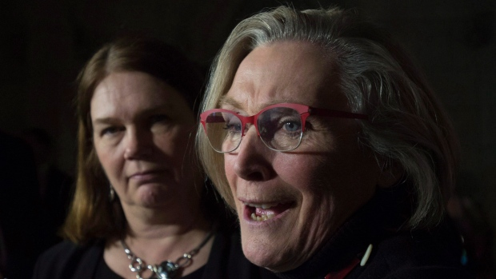
Minister of Health Jane Philpott listens as Minister of Indigenous and Northern Affairs Carolyn Bennett responds to a question in the foyer of the House of Commons. (Adrian Wyld/Canadian Press)
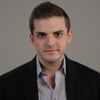
John Paul Tasker
Parliamentary Bureau
John Paul (J.P.) Tasker is a reporter in the CBC's Parliamentary bureau in Ottawa. He can be reached at john.tasker@cbc.ca.
The federal government's attempt to close the gap in health care outcomes for First Nations children is progressing at a snail's pace in some provinces because Ottawa has spent only a fraction of the money it set aside for treatments, according to documents shared with CBC News.
The Canadian Human Rights Tribunal ruled, more than a year ago, that the federally run First Nations health care system is discriminatory and demanded the government provide services to Indigenous kids at the same level as those provided by the provinces to children living off-reserve.
'I think what you're seeing is just how callous they are'- NDP MP Charlie Angus
The tribunal has twice issued non-compliance orders, chastising the government for not fully implementing Jordan's Principle, which stipulates that no Indigenous child should suffer denials, delays or disruptions of health services available to other children due to jurisdictional disputes.
Jordan's Principle is named after Jordan River Anderson, a four-year-old boy with serious and complex medical needs who died in hospital in 2005 after a drawn-out court battle between the federal government and Manitoba over who should pay his home-care costs.
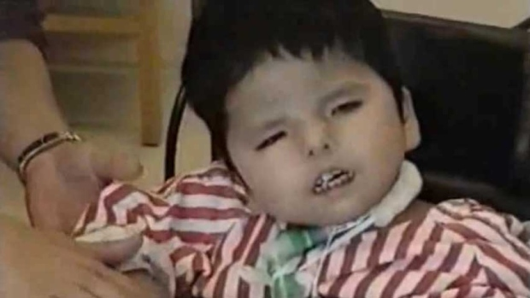
Jordan Anderson is seen in this 2003 video provided by the Assembly of Manitoba Chiefs. Anderson, who was from the Norway House Cree Nation in Manitoba, was born with a complex genetic disorder that needed specialized care. He died in 2005 at the age of five. (Assembly of Manitoba Chiefs)
The government rolled out new funding — up to $382 million over three years — last summer amid calls from critics to implement Jordan's Principle and fix health care disparities, but documents introduced in court show Ottawa is not spending anywhere near the budgeted amount.
The new funding had been earmarked for services previously denied by Health Canada — but offered by the provinces — such as mental health supports, home care and help for children living with disabilities and for things as basic as formula for infants with dietary issues, hearing aids and wheelchairs for paraplegics, among other services.
Unlike other children, health services for First Nations living on reserve are funded almost exclusively by the federal government.
Indigenous Affairs Minister Carolyn Bennett and Health Minister Jane Philpott, who together share the First Nations health care file, have pointed to this new funding as proof the government is complying with the tribunal's demands. The figure was also invoked when defending the government's actions in the face of the recent Wapapeka suicide crisis.

Government has spent $11.4 million
And yet the government has so far spent only $11.4 million in this fiscal year, a far cry from the $127.3 million it earmarked last July, according to documents Indigenous and Northern Affairs Canada and Health Canada filed with the tribunal last month, which were obtained by the NDP, and subsequently shared with CBC News. (The government's fiscal year ends March 31.)
"I think we have a government that is misrepresenting basic facts about First Nations children who are in dire need of medical and mental health care. Their own documents show that they've taken the cheapest option. To get up and say you're flowing money — when you're not — is disingenuous and is leaving children at risk," NDP MP Charlie Angus told CBC News, pointing to a recent interview Bennett did with CBC Radio's The Current, in which she said the government is spending some $200 million this year on health and child welfare services.
The new money has allowed 1,500 more children to access health care, but the vast majority of the new allotment (91 per cent or 1,391 children) has been spent on children in Manitoba and Saskatchewan.
In Ontario, for example, only 22 First Nations kids have had treatments covered by the new Jordan's Principle funding.
The numbers, which are current as of Jan. 11, 2017, are equally low in other provinces with large populations of First Nations: 14 children helped in all of Atlantic Canada, 10 in Quebec, 16 in Alberta, four in B.C., and only one child from the North.
Health Canada did not provide comment in time for this story's deadline but said Wednesday the number of cases is "regularly revised upward," as the department identifies children in need, noting roughly 3,000 children in total have been "approved for coverage" under the Jordan's Principle program as of Feb. 8, which represents about $30-40 million in expenditures for the next fiscal year.
"Funds are being swiftly allocated to support children as soon as they are identified and to ensure arrangements are in place to provide access to needed services," a spokesperson for the department said in statement emailed to CBC News.
While spending in this fiscal year has fallen well short of its budget, Health Canada said the money "will remain available" to help children in future years.

'Fire a whole whack of officials'
An Indigenous Affairs official, speaking on background, defended the numbers by saying the Non-Insured Health Benefits Program is a claims-based process and money is only spent when there is a request for payment from a patient or service provider.
'The minister should be firing staff and I think we should be replacing the minister'- NDP MP Charlie Angus
"I think what you're seeing is just how callous they are," Angus said. "Essentially they're saying 'Unless people come to us, and fight for it, and beg for it, and fill out all the forms, we won't pay.'"
"[Bennett] has told me she's got officials at Indigenous Affairs beating the bushes, trying to go out and find these children. If all they can find is 22 children, then the least we can do is fire a whole whack of officials. The minister should be firing staff and I think we should be replacing the minister. It's either woeful negligence or serious incompetence — children's lives are at stake."
Angus said it's unfathomable that only 22 First Nations children in Ontario have needed medical care in the last six months, when there are 26 high-risk children with mental health needs living on Wapekeka First Nation alone.
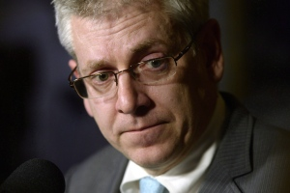
NDP MP Charlie Angus says Health Canada's approval process for Jordan Principle cases is "callous." (Adrian Wyld/Canadian Press)
"I find it really hard to believe that they're waiting for people to come forward. They're turning down applications all the time. They regularly turn down requests for medical treatment for children; you can't have it both ways," Angus said.
Wapekeka First Nation officials say they had applied, unsuccessfully, for funding for help with suicide prevention last summer, ahead of the suicides of two 12-year-old girls this January.
Health Canada said the numbers vary greatly from province to province because of "different on-the-ground realities."
"We have mobilized staff across the country to work with local partners and service organizations to identify First Nations children who need help and to get them the services they require," the Health Canada statement said.

